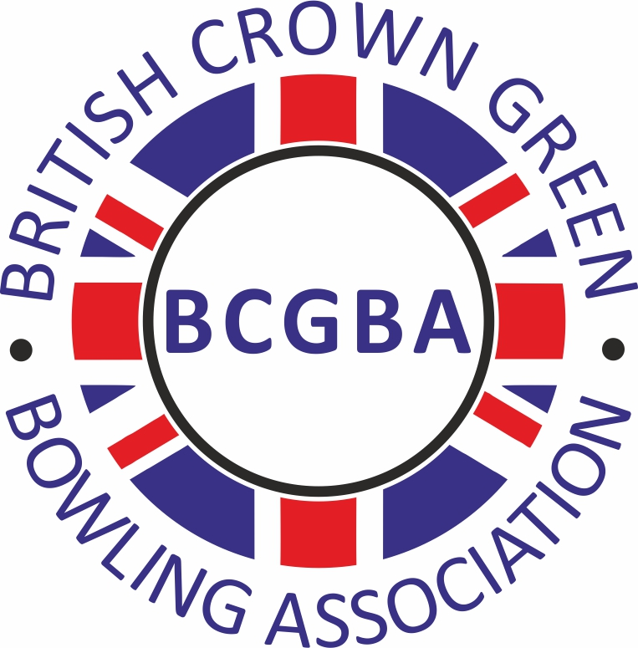
British Crown Green Bowling Association

GRANT APPLICATION

Please complete this form clearly - in BLOCK CAPITALS AND BLACK INK.
COUNTY ASSOCIATION
CLUB NAME
CLUB ADDRESS |  |  |  | CLUB SECRETARY NAME / ADDRESS
Post Code |  |  |  | Post Code
How many greens have you? |  |  |  | Email
How many other Clubs share your green? |  |  |  | Telephone

Please state the purpose of your Grant

Is Planning Permission necessary? | YES/NO | If YES - has it been obtained? | YES/NO
Has work commenced? | YES/NO | If YES - give the date of commencement:
Have you previously received a BCGBA Grant? | YES/NO | If YES - enter amount
Is there any other Grant Aid involved? | YES/NO | If YES - enter amount and from who
What is the total cost of your project?
What is/was the date of completion?

I certify that the above information is correct and complete.
Signed: | (Club Secretary) | Date:
I certify that the above information is correct and complete and they have paid their BCGB Club Fee
Signed: | (County Secretary) | Date:

PLEASE ENSURE THAT THE FOLLOWING DOCUMENTATION IS INCLUDED WITH YOUR APPLICATION
a) Copies of any Planning Permission, Sketch/Plans, Photographs, Quotations and any related documents
b) A copy of your Club's latest Annual Accounts
c) A copy of your Club's current Public Liability Policy Certificate
d) Name and DBS number of your Club's Safeguarding Officer

BCGBA National Administrator - Brian Hampson
2 Braunton Road, Wallasey CH45 5HL
admin@bcgba.org.uk

