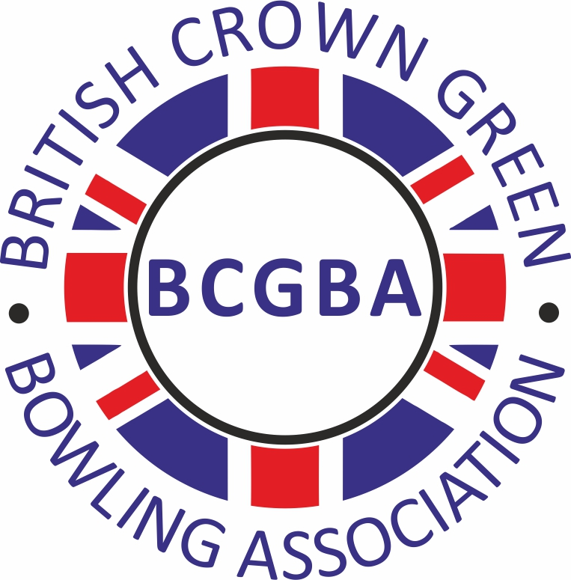
British Crown Green Bowling Association

BCGBA OPEN CONTEST CERTIFICATE
APPLICATION FORM

Before an Open Contest Certificate can be issued, all applications must be approved by the
County Association Secretary of the county in which your competition is being played

NAME OF COMPETITION
Name of Cub
Address
Post Code
Promotor’s Name
Email
Mobile Number
How would you like to receive your certificate – Email or Post
COMPETITION DETAILS
Maximum number of entries
Entry Fee
First Prize
Final Date / Time
Qualifying Dates / Time
SIGNED (Competition Organiser) |  |  |  |  |  | DATE
SIGNED (County Sectary) |  |  |  |  |  | DATE

Please return, fully completed, to your County Secretary.
Once your application is approved payment details will be advised.

The information contained in your application will be used to produce an online Competition Diary, which will be available to view on the BCGBA website – bcgba.org.uk. No personal information will be disclosed (unless requested).

